***Implementation of Inner Classes:***

**Implementation using Inner classes:**

**code:**

package innerclass11;

class TestMemberOuter1{

private int mark=30;

class Inner{

void msg()

{

System.out.println("The obtained mark is "+ mark);

}

}

public static void main(String args[]){

TestMemberOuter1 obj=new TestMemberOuter1();

TestMemberOuter1.Inner in=obj.new Inner();

in.msg();

}

}

**Output:**

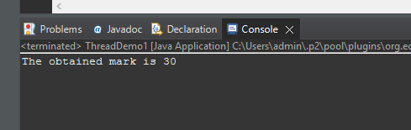

**Implementation using Anonymous inner class:**

**Code:**

package innerclass11;

abstract class Teacher{

abstract void Write();

}

class TestAnonymousInner{

public static void main(String args[]){

Teacher p=new Teacher(){

void Write(){System.out.println("\nThis is Maths Class.");}

};

p.Write();

}

}

**Output:**

